Acknowledgements
Acknowledgement of Country
The Torres and Cape Suicide Prevention Community Action Plan (Torres and Cape SPCAP) acknowledge the Traditional Owners and Custodians of the land, sea and waterways of the Torres and Cape region. We honour their Elders, leaders, and families, past, present and emerging. We respect their continued cultural and spiritual connection to country, kin, community and lore. Through the development and implementation of the Torres and Cape SPCAP, we are committed to making a valued contribution to the wellbeing of all Aboriginal peoples and Torres Strait Islander peoples.

To acknowledge Country means to acknowledge the loss and grief of First Nation Peoples — the profound and ongoing trauma of forced removals of any and all Aboriginal Peoples from their ancestral homeland, and the ongoing negative impact this has on the generations that follow.

Lived experience
The Torres and Cape SPCAP acknowledges and honours the bravery and resilience of people with lived or living experience of suicide and recovery — those who experience or live with suicidal thoughts, survived a suicide attempt, cared for someone through a suicidal crisis, or been bereaved or impacted by suicide.

It is also imperative that the project acknowledges that lived experience is significantly different for Aboriginal and Torres Strait Islander peoples. A First Nations acknowledgement of lived experience recognises the effects of ongoing historical trauma due to colonisation and the removal and dispossession of people from Country and culture. As such, we must take into consideration ways of understanding First Nation social and emotional wellbeing because it encompasses the cultural, spiritual, physical, emotional and mental wellbeing of the individual, within the family, and outward into the Clan and broader community.

The Torres and Cape SPCAP intention is to ensure the voice of people with lived experience of suicide and recovery informs the way suicide is spoken about, understood and ultimately prevented.

Torres and Cape SPCAP partnership
We acknowledge the contributions of the organisations who worked in partnership to develop the Torres and Cape SPCAP, including Northern Queensland PHN, Torres and Cape HHS, Wakai Waian Healing, Northern Peninsula Area Family and Community Services, Queensland Royal Flying Doctor Service, Apunipima Cape York Health Council and Beacon Strategies. We also acknowledge the funding contribution of the Commonwealth Government Department of Health for this activity.

Acknowledgement of participation
We acknowledge the experiences, insights and wisdom shared by all those who participated in the development of this SPCAP — through surveys, conversations in communities, meetings, workshops or written submissions. Your contribution to the development and ongoing implementation of the Torres and Cape SPCAP is fundamental in reflecting the needs and aspirations of communities.

Foreword

In 2021 we lost our 37-year-old son to suicide. He has left behind two beautiful children aged ten and six, three sisters, extended family, friends, and devastated parents. It has been and still is extremely dark times for our family as we try to survive this complicated grief and learn to live with our experience of this tragedy. Unfortunately, there is a growing number of suicide loss survivors, across all the different cultures, living on the Cape York Peninsula and the Torres Strait Islands.

In the past, topics such as mental health and suicide were hidden away and never mentioned as people were shamed and stigmatized if they spoke about it. In this silent aloneness it was a struggle for people to reach out for help. Over the years with education around mental health, and through organisations like Black Dog Institute, the attitude to this illness is slowly changing and people are now brave enough to speak about it. Roses in the Ocean has really led the way for people to tell their story to the wider community which breaks down those barriers of shame and judgement.

It was a wonderful opportunity when I saw the invitation to take part in the consultation process with Torres and Cape Suicide Prevention Community Action Plan. It was a chance to turn my loss into something to help others and to channel my grief somewhere for a purpose. My participation in this project has been my way to honour my boy who lived with that silent aloneness. I needed to speak up for him and for others that did not receive the help they deserved.

The nine strategies in the Black Dog Institute Lifespan framework are just common sense, in light of what has been lacking in our mental health services over the years. As a parent of someone who had ongoing mental health issues, I know that it is essential to involve the family and community in care and decision-making around what is best suited for the ones we love. Improving emergency and follow-up care as well as training and improving competency in recognizing and supporting people who are distressed are essential skills to empower our communities and the organisations that service us. Our children need to be educated to seek help and for resilience skills to be prioritised as just as important as literacy and numeracy in our schools.

Congratulations to Torres and Cape Suicide Prevention Community Action Plan for adopting such a well-balanced community-focused plan that includes recommendations from those of us who have had this life experience. Suicide prevention is the responsibility of individuals, families, workforces, health services, schools, communities, and the government. Together we can reduce the rates of suicide.

- Jackie Perry
Lived Experience Participant, Torres and Cape Suicide Prevention Community Action Plan

Introduction

About the Torres and Cape SPCAP

The Torres and Cape Suicide Prevention Community Action Plan (SPCAP) provides a framework for a coordinated and agreed systems-based approach to preventing suicide in communities across the Torres and Cape region.

It has been jointly developed over a 12-month period during 2021-2022 through partnership between Northern Queensland PHN and members of the project steering group: Torres and Cape HHS, Wakai Waian Healing, Northern Peninsula Area Family and Community Services, Royal Flying Doctor Service and Apunipima Cape York Health Council.

The Torres and Cape SPCAP uses the LifeSpan framework, developed by Black Dog Institute, as a guide to implementing a systems-level approach to suicide prevention. Utilising such a framework allows communities and stakeholders the flexibility to adapt priority actions to meet the needs of their local community whilst adhering to evidence-based suicide prevention approaches.

The Torres and Cape SCAP aspires to bring together the experiences, wisdom and strengths of local communities, the expertise of professional stakeholders working in suicide prevention and other support services, and the leading evidence on suicide prevention to respond to the diversity and uniqueness of the Torres and Cape region.

Purpose of this document

This Strategy document forms one part of a suite of documents produced in the development of the Torres and Cape SPCAP.

This Suicide Prevention Community Action Plan Strategy aims to:
- introduce the background and context
- provide an overview of the Torres and Cape region
- summarise the needs and issues identified within local communities relating to suicide prevention
- outline priority actions and impact indicators across a range of components mapped to Black Dog Institute’s LifeSpan framework.
- describe how the ongoing implementation and governance of the SPCAP will be led.

The Torres and Cape SPCAP is presented as a three-tier composite document aimed at giving the right amount of detail for the appropriate respective audience. By using a suite of documents, it is also hoped that we can ensure that the high-level strategy is clear and succinct, that we have respected and retained all of the detailed information that was collected throughout the project and that the plan for implementation is bound to a short time frame and achievable.
Torres and Cape SPCAP: Report — the purpose of the report is to transparently outline our approach, share the findings of the desktop research, profile each of the regions in more detail and provide a summary of what we have learned so far in talking with community members, people with a lived experience and sector professionals across the Torres and Cape region.

Torres and Cape SPCAP: Strategy — a document that briefly summarises the needs of the Torres and Cape region but predominantly focuses on outlining priority actions and impact indicators aligned to Black Dog Institute’s LifeSpan framework, and describing the ongoing implementation and governance efforts.

Torres and Cape SPCAP: Actions Register — an evolving document that will capture region-level and local-level implementation activities, including who is responsible, how implementation activities will be rolled out and by when. The actions register will be collaboratively developed in response to the Strategy and Report by the relevant project governance mechanisms.

About the Torres and Cape region
The Torres and Cape region refer to the area that is covered by the Torres and Cape Hospital and Health Service (TCHHS). Over 25,000 people live in the Torres and Cape region, with around 2 in 3 people identifying as an Aboriginal and/or Torres Strait Islander person.

The communities within the four Torres and Cape regions are considerably diverse. The three main clusters of island groups that make up the Torres Strait Island region (West, Central and East) have their own unique cultural norms and language variations. The Northern Peninsula Area has communities that are Aboriginal but predominantly Torres Strait Islanders. Some communities, like Weipa in the Western Cape region, are made up of resource (mining) workers who either reside on-site or fly-in fly-out, and some communities in the Cook shire are rural farming populations who live alongside Indigenous peoples in their ancestral homeland.

The nature and the diversity of the Torres and Cape region require a suicide prevention strategy that is culturally and geographically appropriate and community-focused, owned and operated.

Torres Strait Islands
- Covers 48,000 sq km of sea that contains an archipelago of 274 islands; 17 of which are inhabited by 18 Indigenous communities.
- A population of approximately 7,490 people
- Includes five traditional island clusters each with their own unique culture and language

Northern Peninsula Area (NPA)
- Covers a geographical area of 1,052 sq km located at the very northern tip of Australia
- A population of approximately 3,069 people
- Lands of the Atambaya, Gudang, Yadhaykenu, Ankamuthi, Wuthathi, and Kaurareg peoples
- Includes three Aboriginal communities of Injinoo, New Mapoon and Alau (Umagico) and two Torres Strait Islander communities of Bamaga and Seisia.

Western Cape
- Located in the Western part of Cape York Peninsula area
- Lands of the Wik, Wik Way, Kugu, Kokoberra, Yir Yoront, Kunjen, Thaayorre, Mungkan and Alngith peoples
- Includes communities of Weipa (a township operated by Rio Tinto), Aurukun, Kowanyama, Napranum, Pormpuraaw and Mapoon.

Shire of Cook
- Covers most of the eastern and central parts of Cape York Peninsula area, with a geographical area of 105,000 sq km of land
- Population of approximately 4,595 people
- Includes three discrete Aboriginal councils (Lockhart River, Hope Vale and Wujal Wujal) as well as the largest local council in Queensland (Cook Shire) taking in the communities of Cooktown, Laura, Coen, as well as the smaller communities of Lakeland, Rossville, Ayton, and Portland Roads, as well as offshore islands including Lizard Island.

For a more detailed overview of each region, see the Torres and Cape SPCAP: Report.

How the plan was developed

The development of the Torres and Cape SPCAP began in August 2021. The process so far has been both insightful and sombre, with many highlights to report, including:
- Comprehensive desktop research to understand the historical and social determinants of suicide throughout the Torres Strait Islands and Cape York Peninsula regions.
- Ensuring that the diverse nature and differences between the unique communities which comprise the Torres Strait Islands and Cape York Peninsula areas are understood and embedded in planning, including but not limited to; geography, distance, demographics, socio-economics, as well as cultural and spiritual protocols and practices.
- Establishing the Torres and Cape SPCAP Project Steering Group (PSG) in September 2021 with membership from NQPHN, TCHHS, Wakai Waian Healing, Queensland Royal Flying Doctor Service, Apunipima Cape York Health Council, NPA Family and Community Services Aboriginal and Torres Strait Islander Corporation and Beacon Strategies.
- Based on feedback from the PSG in October, redefining the project's geographical footprint to include Coen, Hopevale and Laura in the Cook Shire region.
- Delivering a 5-day consultation throughout the Cook Shire region with sector professionals and workers in early November 2021; visiting the communities of Wujal Wujal, Cooktown, Hopevale, Coen and Laura.
- Delivering a 5-day consultation throughout the greater Weipa region with sector professionals and workers, including the Napranum and Mapoon communities in mid-November 2021.
- Delivering a 5-day consultation in the Torres Strait Islands region with sector professionals and workers, visiting the Islands of Nurupai (Horn) and Waiben (Thursday) in early December 2021.
- Based on feedback from the PSG in January 2022, redefining the project's geographical footprint to include the communities of Aurukun, Kowanyama and Pormpuraaw to create a whole of Western Cape region.
- Delivering a 2-day consultation in the Northern Peninsula Area region with sector professionals and workers from the communities of Bamaga, New Mapoon, and Alau (Umagico) during May and June 2022.
- Publishing a “call for support” editorial in the Cape York Weekly newspaper, seeking to give a voice to those with LE and having nine people from across several regions contact the project wanting to share their stories and improve suicide prevention services.
- Conducting 6 face-to-face LE consultations in remote community settings and 5 teleconference consultations with LE participants representing the TSI, Weipa and Cook shire regions.
- Via the consultation process, with both sector and LE participants, enabled connection and facilitated the development of a regional cross-cultural postvention initiative in the Cape York area, in addition to a localised support group for those bereaved by suicide.
- Delivered 2 x 2-day consultations in June 2022 with the communities of Kowanyama and Pormpuraaw in the Western Cape region.
- Coordinating and delivering a series of 5 project steering group meetings to hear from prominent sector stakeholders about the biggest issues, brightest solutions and future vision for suicide prevention activities across the Torres and Cape

The need for a suicide prevention community action plan

Policy environment

National and state policies call for tailored, place-based, cross-sectoral, collaborative and culturally appropriate responses to preventing suicide in communities.

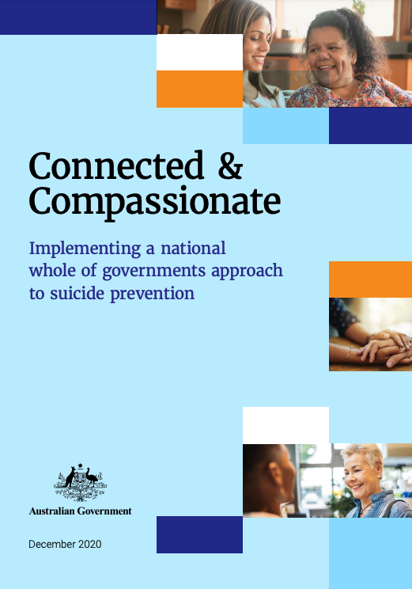
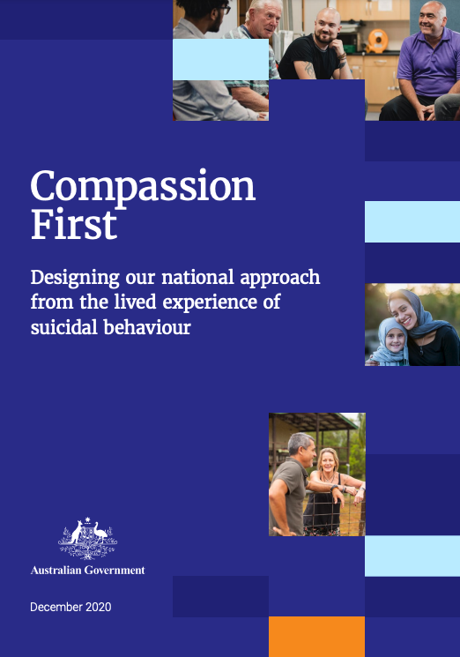
Compassionate First report: National Suicide Prevention Adviser – final advice
The final advice of the First National Suicide Prevention Adviser to the Prime Minister of Australia advocates for broad collaboration to drive change in suicide prevention nationally.

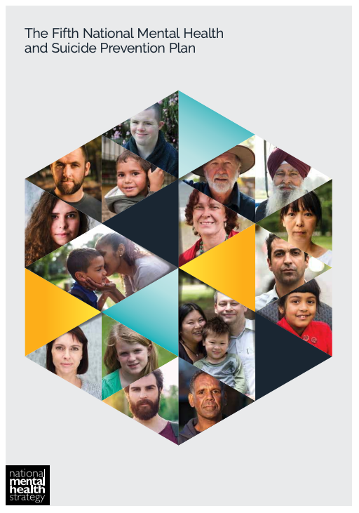

Fifth National Mental Health and Suicide Prevention Plan
A priority action of the Fifth Plan is for PHNs and local hospital networks to develop integrated, whole-of-community approaches to suicide prevention through engaging with local communities and taking coordinated action.

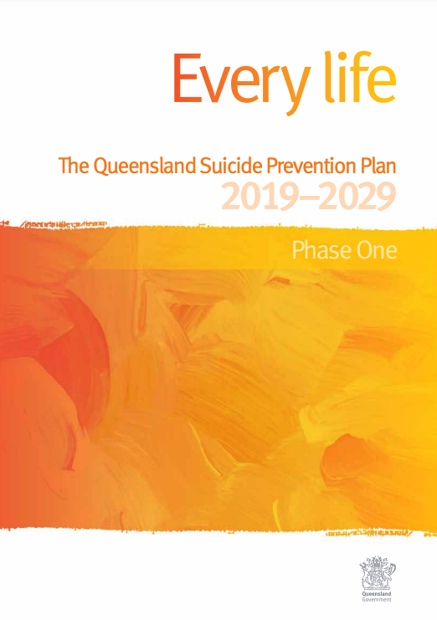

Every Life: The Queensland Suicide Prevention Plan 2019-2029
The Queensland Suicide Prevention Plan 2019-2029 calls on all sectors and communities to work together to prevent suicides through connected and informed planning and coordinated approaches at national, regional and local levels.

At a regional level, key planning documents published by Northern Queensland PHN and Torres and Cape HHS commit to a system-based, community-led approach to preventing suicide.
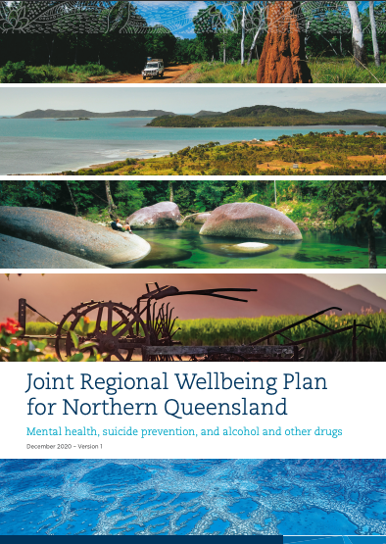

Joint Regional Wellbeing Plan for Northern Queensland
Northern Queensland PHN and Torres and Cape HHS are signatories to the Joint Regional Wellbeing Plan for Northern Queensland committing both organisations to the implementation of the LifeSpan framework.
Key outcomes outlined in the joint plan include establishing coordination of regional community action plans, coordinated access to services, appropriate aftercare and postvention responses, and reduced suicide rates.

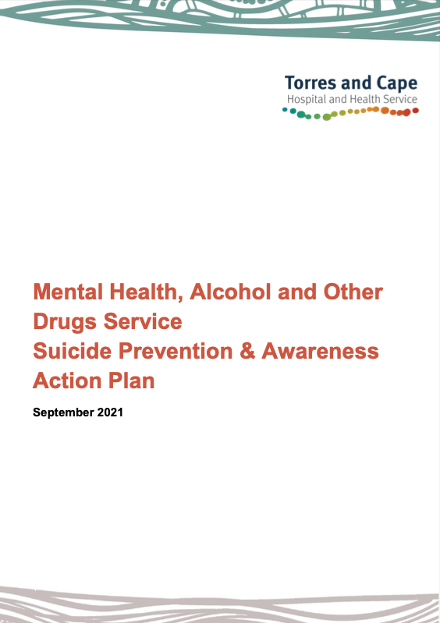

Torres and Cape HHS Mental Health, Alcohol and Other Drugs Service, Suicide Prevention & Awareness Action Plan 2021
The Torres and Cape Action Plan describes a vision for a coordinated approach to suicide prevention and management across TCHHS inclusive of key stakeholders and service partners.

Lifespan framework
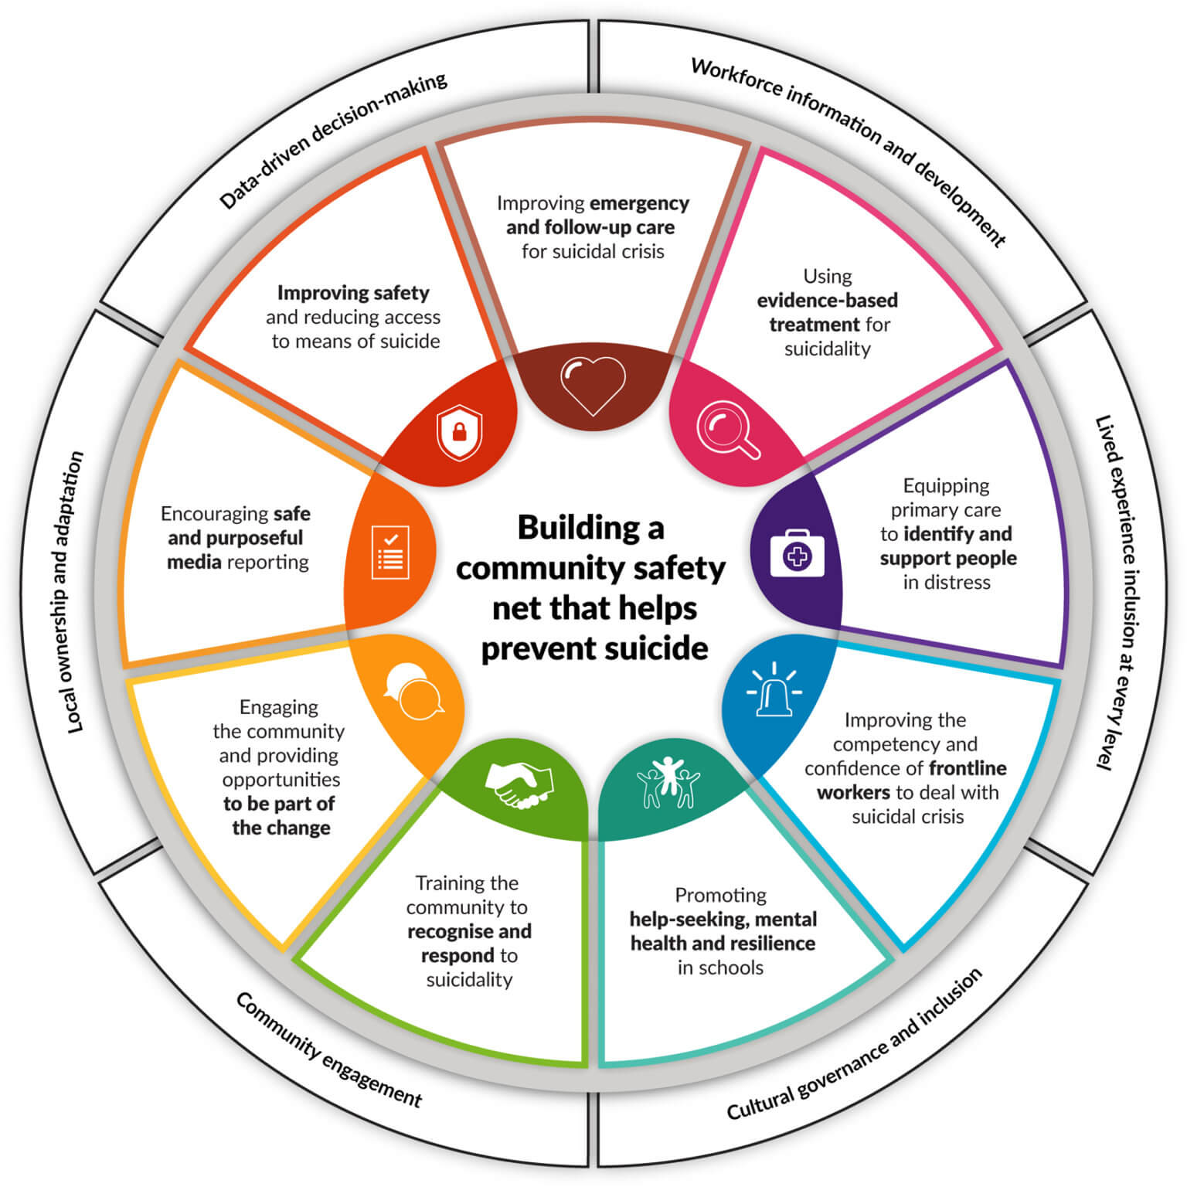
Black Dog Insitute’s LifeSpan is an integrated framework for suicide prevention.

LifeSpan involves the implementation of nine evidence-based strategies for suicide prevention as part of one community-led approach incorporating health, education, frontline services, business and the community.

These nine strategies are implemented from the whole-of-population to the individual level, simultaneously within a localised region. A range of principles underpins the effective implementation of the LifeSpan Framework, highlighted in more detail later in this report.

LifeSpan has been used as the guiding framework in developing the Torres and Cape SPCAP as the leading example of an evidence-based, systems-based approach to suicide prevention. It is acknowledged that adaptation of the LifeSpan framework is required if it is to meet the needs of First Nations communities.

Regional suicide data profile

The number and rate of deaths by suicide in the Torres and Cape region are not reported due to the small population size. However, anecdotal reports from many communities in the region describe being impacted by suicide loss as a byproduct of significant historical and complex trauma.

Remoteness, a high proportion of Aboriginal and Torres Strait Islander people and socioeconomic vulnerability, highlight the unique needs of Torres and Cape relative to other parts of Queensland and Australia.

The causes of suicide are complex and multifaceted. Suicide is not always related to a diagnosed mental illness. Suicidal thoughts or attempts are often linked to feelings of helplessness or being overwhelmed by stressful life events. Factors that protect against suicide include social and emotional wellbeing, connection to culture and community, as well as access to services.

Northern Queensland PHN’s Health Needs Assessment identified a lack of access to mental health services including suicide prevention programs and Indigenous-specific responses in rural and remote areas of Northern Queensland. Additionally, it was stated that the Torres and Cape region had a high rate of hospitalisations for intentional self-harm, mental health and alcohol-related issues compared to national, state and regional averages.

Consultation themes

Consultation with service system stakeholders, local community members and people with lived experience of suicide highlighted several consistent, high-level themes:
- Significant stigma and shame around seeking help and speaking about suicide
- Community awareness and education around mental health and suicide prevention
- Availability, accessibility and continuity of social and emotional wellbeing services
- Appropriateness and effectiveness of service models in meeting people’s needs
- Culture as a source of strength, therapeutic support and healing
- Experiences of complex loss, grief and trauma
- Holistic social and emotional wellbeing
- Alcohol and substance misuse
- Socioeconomic vulnerability and social determinants of wellbeing
- Workforce and organisational development and support
- Interagency collaboration and coordination
- Funding and resourcing of supports relating to suicide prevention

A more detailed report of the findings of consultation with communities in developing the Torres and Cape SPCAP — including the issues and experiences identified by local communities in the Torres Strait Islands, Western Cape, Northern Peninsula Area and Cook Shire — can be found in the Torres and Cape SPCAP Report.

Service system

The service system that supports people and communities throughout the Torres and Cape region consists of:
- Acute, specialist and emergency health care delivered by 4 hospitals operated by Torres and Cape HHS (Cooktown, Weipa, Thursday Island, Bamaga), visiting health services and facilitated by transfer to other regions
- Primary health care services delivered by 31 primary health care centres operated by Torres and Cape HHS, Aboriginal community-controlled health services and non-government organisations
- Stepped care mental health services and social and emotional wellbeing services delivered by community-based providers funded by NQPHN
- Family and community support services delivered by community
- Local schools
- Local government

Strategy

Vision

The vision of the Torres and Cape Suicide Prevention Community Action Plan is to:

Prevent suicide and suicide attempts across the Torres and Cape region, and reduce the impact that suicide has on families and communities.

Outcomes

The desired outcomes of the Torres and Cape Suicide Prevention Community Action Plan are:

- Establishing implementation and governance mechanisms that support local action as part of a regional approach
- Improving the coordination and collaboration of suicide prevention-related activities across the broader service system
- Better engagement of people with lived experience of suicide at all levels of the regional suicide prevention system
- Implementing evidence-based strategies across local communities to:
  - stay strong and connected
  - respond earlier and more effectively to suicidality
  - support people in crisis
  - support communities impacted by suicide
- Developing more compassionate, effective, accessible, culturally appropriate and sustainable service delivery models for the unique context of the Torres and Cape region
- Eliminating stigma and shame around suicide and help-seeking
- Reducing suicide deaths, suicide attempts and hospitalisations relating to suicidal crisis.

Principles

The principles that will guide the implementation of the Torres and Cape SPCAP are based on the Black Dog Institute’s LifeSpan framework:

- Data-driven decision making - Planning of suicide prevention activities is evidence-based, informed by collecting, analysing, interpreting and mapping available data that is locally relevant.
- Workforce information and development - Health and community services professionals and frontline workers play a critical role in suicide prevention. Training and knowledge sharing are key to supporting workers in preventing suicide.
- Lived experience inclusion at every level - We acknowledge the invaluable contribution of those with a lived experience of suicide, who must be included at all stages of decision-making, implementation, and evaluation of the SPCAP.
- Local ownership and adaptation - Local communities must own the implementation of the SPCAP. Actions have intentionally been left high-level so that localised implementation teams may adapt them to suit the region.
- Community engagement - The community all have a role to play in suicide prevention. As much as possible, the plan’s implementation should be community-led and should be designed to meet community needs.
- Cultural governance and inclusion - Any initiative done within Aboriginal and Torres Strait Islander communities must be led and owned by the community to ensure that they are done in the best interest of the community and in the most appropriate way.

Priority populations

To ensure the Torres and Cape SPCAP is understanding and effectively responding to those who experience relatively higher levels of vulnerability around suicide, the development and ongoing implementation of the SPCAP will have a targeted focus on several priority population groups:

- Aboriginal and Torres Strait Islander Peoples
- Male resource and rural workers aged 35-44 years
- Young people: rural, remote and First Nations

Key components

The Torres and Cape SP-CAP are based on the nine components outlined in Black Dog Institute’s LifeSpan framework, a systems-based approach to suicide prevention at a community level.

These components include:

- Improving emergency and follow-up care for suicidal crisis
- Using evidence-based treatment for suicidality
- Equipping primary care to identify and support people in distress
- Improving the competence and confidence of frontline workers to deal with suicidal crisis
- Promoting help-seeking, mental health and resilience in schools
- Training the community to recognise and respond to suicidality
- Engaging the community and providing opportunities to be part of the change
- Encouraging safe and purposeful media reporting
- Improving safety and reducing access to means of suicide

For each of these components, the Torres and Cape SPCAP includes the following information outlined on the subsequent pages:

- Explainer — a description of the component and the evidence that supports its impact on suicide prevention outcomes as outlined in the LifeSpan framework

- What we’ve heard — a summary of relevant findings relating to the component captured through consultation with local system stakeholders, community members and people with lived experience of suicide.

- Priorities for action — the strategies and solutions that can be implemented within each component to meet the needs of communities. Each of these priorities will inform local implementation supported by a regional approach.

Summary of priority actions

The Torres and Cape SPCAP has identified 27 priority actions for preventing suicide attempts and deaths across the region, aligned to the 9 domains of Black Dog Institute’s LifeSpan framework. It is obvious that all of these actions won’t be able to be implemented immediately or simultaneously, some can be implemented across the entire region whilst others will be implemented by communities across the Torres and Cape region when the time is right. The priority actions listed below will provide a flexible framework for the delivery of suicide prevention activities across the Torres and Cape region.

LifeSpan Domain | Priority actions
Domain 1: improving emergency and follow-up care for suicidal crisis | Priority action 1.1 — training for frontline healthcare workers
 | Priority action 1.2 — commission culturally and geographically relevant aftercare services.
 | Priority action 1.3 — establish aftercare referral pathways and discharge protocols
 | Priority action 1.4 — review Torres and Cape HHS and community-controlled organisations workforce mix
 | Priority action 1.5 - maintaining access to localised specialist care teams in times of crisis: establish clear referral and care pathways for people experiencing psychological crisis
Domain 2: using evidence-based treatment for suicidality | Priority action 2.1 — develop locally specific mental health and suicide prevention interagency forums and case conferencing meetings
 | Priority action 2.2 — scope and establish alternatives to emergency departments: localised initiatives
 | Priority action 2.3 — commission locally available mental health supports
 | Priority action 2.4 — suicide prevention training for community workers and mental health professionals
 | Priority action 2.5 — make available localised, de-identified suicide prevention data
 | Priority action 2.6 — support the distribution of best-practice suicide prevention approaches
Domain 3: equipping primary care to identify and support people in distress | Priority action 3.1 — provide suicide prevention specific training for primary care health professionals (including GPs)
 | Priority action 3.2 — scope the development of a geographically and culturally appropriate primary care oriented screening tool and referral pathway
Domain 4: improving the competence and confidence of frontline workers to deal with suicidal crisis | Priority Action 4.1 — suicide prevention training and supervision for first responders
 | Priority Action 4.2 — suicide prevention protocols (responding to attempts and postvention)
 | Priority Action 4.3 — explore innovative first responder service models
 | Priority Action 4.4 — develop First Nations first responder workforce
Domain 5: promoting help-seeking, mental health and resilience in schools | Priority action 5.1 — whole-of-school approaches to suicide prevention (including education, resources and referral pathways)
 | Priority action 5.2 — programs for children and young people not engaged in the education or vocational training system
 | Priority action 5.3 - sports and out of school activities to be developed and implemented
Domain 6: training the community to recognise and respond to suicidality | Priority action 6.1 — suicide prevention training for community members
 | Priority action 6.2 — build local networks of trained community members
Domain 7: engaging the community and providing opportunities to be part of the change | Priority action 7.1 — develop culturally and geographically relevant communication campaigns
 | Priority action 7.2 — establish suicide prevention and support networks for community members
 | Priority action 7.3 — train lived experience representatives to participate in project governance activities
Domain 8: encouraging safe and purposeful media reporting | Priority action 8.1 — collaborate with traditional regional media outlets to deliver safe and purposeful media reporting
 | Priority action 8.2 — develop strategies with regional stakeholders and community groups regarding safe and purposeful social media content
Domain 9: improving safety and reducing access to means of suicide | Priority action 9.1 — region-wide culturally and geographically appropriate approach to safety planning
 | Priority action 9.2 — scope the feasibility and utility of conducting a Suicide Audit Report

Priority actions in more detail

Component 1: Improving emergency and follow up care for suicidal crisis
A suicide attempt is the strongest risk factor for subsequent suicide. A coordinated approach to care for people after a suicide attempt is essential to reduce the risk of future attempts.

Coordination of care is complex and emergency departments are high-pressure environments where staff are time-poor. Often, people who present in emergency departments (EDs) for suicidal thinking or attempts don’t receive the care and support they need.

Evidence shows that it is the experience rather than strict adherence to a protocol that makes the difference between good and poor care. When people seek help, services need to make them feel validated, welcome and heard.

Source: Black Dog Institute’s LifeSpan Framework

What have we heard?

We have heard from people with a lived experience, members of the community and sector professionals that:

- After hours waiting times for accessing suicide prevention services are too long in times of crisis
- Outpatient waiting times for community suicide prevention and mental health services post discharge are considered too long
- Linkage between Torres and Cape HHS facilities with a range of health and social support organisations (e.g. family and domestic violence, alcohol and other drugs, mental health, and many more) could be improved to enhance holistic, interconnected service delivery
- The availability of culturally appropriate suicide prevention aftercare support delivered within remote community settings is limited
- The availability of Torres and Cape HHS employed community support personnel (e.g. link workers, social workers and/or care coordinators) is limited leading to suboptimal discharge planning processes
- Procedures and protocols regarding the coordination of Torres and Cape HHS patients with relevant community based aftercare services aren’t clearly defined
- Staff working within the Torres and Cape HHS have an appetite to access suicide prevention training to build their knowledge and confidence of supporting people in times of suicidal crisis
- The cultural appropriateness of services provided within the Torres and Cape HHS setting is variable across sites and perceived as limited by the community.

Priorities for action

Across the Torres and Cape region, improving emergency and follow up care for suicidal crisis could be improved through implementing the priority actions listed below:
- Priority action 1.1 — training for frontline healthcare workers: healthcare workers within the Torres and Cape HHS and community controlled entities to receive culturally appropriate suicide prevention training to continually improve how people in suicidal crisis are identified and supported.
- Priority action 1.2 — commission culturally and geographically relevant aftercare services: Northern Queensland PHN, in partnership with Torres and Cape HHS to scope, consider the feasibility of and commission culturally and geographically relevant aftercare services.
- Priority action 1.3 — establish postvention referral pathways and discharge protocols: review referral pathways and procedures to improve access to culturally appropriate and community-based suicide prevention services.
- Priority action 1.4 - maintaining access to localised specialist care teams in times of crisis: establish clear referral and care pathways for people experiencing psychological crisis

Component 2: Using evidence-based treatment for suicidality

Ensuring that accessible and appropriate mental health care is available to those who need it the most.

Mental illness, including depression, is associated with a large portion of suicide attempts. Providing accessible and appropriate mental health care is essential to suicide prevention.

Central to this is ensuring mental health professionals are aware of the latest evidence and best practice care and treatment options. Information sharing between care providers also needs to be enhanced.

Source: Black Dog Institute’s LifeSpan Framework.

What have we heard?

We have heard from people with a lived experience, members of the community and, sector professionals that:

- There are limited options for community members to access support or a safe place after hours, apart from local emergency departments or QPS (which results in criminality). Members of the community would prefer a culturally appropriate safe crisis space to be created to connect consumers with relevant support
- There are limited opportunities for multidisciplinary collaboration between key mental health and suicide prevention stakeholders across the Torres and Cape. Organisations could be developing referral pathways, sharing knowledge and providing more holistic, “wrap-around” care for members of the community experiencing crises
- Interagency forums and case conferencing for individuals experiencing family and domestic violence, alcohol and other drug issues, self-harm, and suicidal ideation are generally not being implemented
- Community organisation's knowledge of trauma-informed practices and comorbidity in relation to domestic and family violence, substance abuse, self-harm and suicide is limited
- The global research base is not being utilised to its fullest potential
- There are no readily available localised statistics on self-harm or suicide to learn and develop a best practice from
- Evidence-based practices should be utilised in conjunction with practice-based evidence (traditional healing) to appropriate effective cultural interventions for Indigenous people who are dealing with trauma, family and domestic violence substance abuse, self-harm and suicidality
- Sector professionals working in health, community services and community-controlled support organisations have limited access to evidence-based practice and professional development opportunities, which are intended to provide upskilling on how to attend, engage, assess, and respond to a person experiencing suicidality
- Sector professionals have told us the skill set of community workers (capability and capacity) focuses primarily on casework, with very few programs or interventions designed, implemented, or evaluated that mitigate the effects of trauma, F&DV, AOD abuse, self-harm or suicide.

Priorities for action

Across the Torres and Cape region, using an evidence-based treatment for suicidality could be achieved through implementing the priority actions listed below:

- Priority action 2.1 — develop locally specific mental health and suicide prevention interagencies: scope and strengthen or establish local interagency collaboration to improve approaches to discharge planning and aftercare, in addition to developing referral pathways to a range of health and social services (e.g. domestic and family violence, alcohol and other drugs and mental health, etc.).
- Priority action 2.2 — scope and establish alternatives to emergency departments initiatives: Northern Queensland PHN, Torres and Cape HHS, local government and service provider organisations to partner and leverage the emerging safe space evidence base to develop culturally and geographically relevant service models to support people in suicidal crisis.
- Priority action 2.3 — commission locally available mental health supports: Northern Queensland PHN to continue to fund mental health and social and emotional wellbeing services across the Torre and Cape region to ensure the availability of local supports.
- Priority action 2.4 — suicide prevention training for community workers and mental health professionals: work with local sector professionals (community workers and mental health professionals working in NGOs) to identify and make available a suite of suicide prevention training opportunities to improve the identification and response to people experiencing suicidal crisis.
- Priority action 2.5 — improve suicide prevention data availability: scope the feasibility of gaining access to local suicide data (TCHHS MHAOD) to improve the targeting and sophistication of suicide prevention initiatives, in addition to establishing and developing a functional dataset over time.
- Priority action 2.6 — support the distribution of best-practice suicide prevention approaches: work directly with stakeholders across the Torres and Cape region who work in the mental health and suicide prevention space, to provide resources, practice guidance and other high-value materials to promote evidence-based practice. Consider partnerships with local universities to leverage their knowledge.

Component 3: Equipping primary care to identify and support people in distress

Suicidal individuals often visit primary care providers in the weeks or days before suicide yet many do not mention their suicidal thoughts to their doctor or if they do, they often don’t receive the care and support they need.

There are many reasons for this including fear, stigma and time pressures. Many General Practitioners (GPs) are unaware of referral points and current best practice care and treatment. Encouraging evidence-based practice and greater integration with other services is critical.

Capacity building and education for primary care providers is one of the most promising interventions for reducing suicide.

Source: Black Dog Institute’s LifeSpan Framework

What have we heard?

We have heard from people with lived experience, as well as members of the community and sector professionals that:

- GPs are essentially accessed through Primary Health Care Centres (PHCCs) or Torres and Cape HHS facilities across the region
- There are limited numbers of GPs available throughout the Torres and Cape, making access and timeliness of service problematic
- The GPs who are available have large caseloads, and therefore members of the community experience long wait times
- GPs are often either unaware of current best practices around identifying and responding to a suicidal crisis or have limited capacity or time to appropriately respond
- GPs are not always aware of referral pathways or what services are available for consumers who make contact with them
- Community members and workers have told us dual relationships were the reason the community don't engage with local medical centres or community controlled support services.

Priorities for action

Across the Torres and Cape region, equipping primary care to identify and support people in distress could be improved through implementing the priority actions listed below:
- Priority action 3.1 — provide suicide prevention specific training for primary care health professionals (including GPs): provide healthcare staff working in primary care with culturally appropriate suicide prevention training to better support them to identify and respond to people experiencing suicidality. Training to include tips on best-practice suicide prevention approaches and the importance of managing dual relationships in remote communities.
- Priority action 3.2 — scope the development of a geographically and culturally appropriate primary care-oriented screening tool and referral pathway: support GPs to deliver evidence-based suicide prevention responses that are culturally appropriate, through exploring the value of investing in evidence-based screening tools, and in the development of locally relevant suicide prevention pathways.

Component 4: Improving the competence and confidence of frontline workers to deal with suicidal crisis

The interactions a suicidal person has with frontline workers such as police, paramedics and emergency department staff, can influence their decision to access and engage with care. Frontline workers can play a key role in de-escalating a crisis and improving safety. However, existing training may not include the latest emerging research and skills require periodic refreshing.

When vulnerable people seek help, frontline staff need to make them feel safe and heard. Evidence shows that it is the experience, rather than strict adherence to a protocol, that can make the difference.

In addition, workers exposed to stressful situations and trauma can themselves become vulnerable to suicide. Offering training to those on the frontline can build their capacity to respond to those in need – both members of the community and their colleagues, who may be vulnerable due to trauma and PTSD.

Source: Black Dog Institute’s LifeSpan Framework

What have we heard?

We have heard from people with a lived experience, members of the community and sector professionals that:

- In many communities, Ambulance and Police (and hospitals) are the most prominent touchpoints relating to suicide prevention
- First responders could improve their effectiveness following a suicide attempt or death by enhancing their knowledge about cultural protocols and suicide prevention best practices
- There is a high demand for tertiary-trained Indigenous first responders across the Torres and Cape region
- First responders exposed to ongoing volatile situations and trauma may vicariously become emotionally and psychologically vulnerable
- There is no formalised structure to postvention protocols or culturally appropriate grief and loss processes for first responders
- There is limited support for health professionals and support workers outside of informal relationships and Employee Assistance Programs (EAP).

Priorities for action

Across the Torres and Cape region, improving the competence and confidence of frontline workers to deal with suicidal crises could be improved through implementing the priority actions listed below:
- Priority Action 4.1 — suicide prevention training and supervision for first responders: working in partnership with Torres and Cape HHS, Queensland Ambulance Service and Queensland Police service to identify and implement culturally and geographically appropriate suicide prevention specific training to better respond to suicidal crisis. Additionally, provide routine debriefing to allow the opportunity for first responders to process traumatic events.
- Priority Action 4.2 — suicide prevention protocols (responding to attempts and postvention): working in partnership with Queensland Ambulance Service and Queensland Police Service, review and refine suicide prevention and postvention protocols to enhance suicide prevention responses whilst allowing families and communities time and space to grieve and heal.
- Priority Action 4.3 — explore innovative first responder service models: explore the establishment of innovative first responder service models, such as; culturally and geographically relevant co-responder type initiatives to deliver a compassionate and effective first response to suicide attempts and deaths.
- Priority Action 4.4 — develop First Nations first responder workforce: advocate for investment in developing a First Nations first responder workforce to improve the cultural appropriateness of service responses.

Component 5: Promoting help-seeking, mental health and resilience in schools

Young people can be particularly vulnerable to mental health problems, self-harm or suicide. Schools are keen to support their students but often don’t know how to choose quality programs or integrate programs with other student wellbeing activities and referral pathways.

Youth Aware of Mental Health (YAM) is designed to raise awareness about suicidality and the factors that protect against it. It works by improving mental health literacy and explicitly teaching the skills necessary for coping with adverse life events and stress, so that young people get help before reaching crisis point. YAM has the strongest evidence base of school programs reviewed including the best outcomes specific to suicidal behaviour, and the flexibility to be integrated into any school environment.

Source: Black Dog Institute’s LifeSpan Framework

What have we heard?

We have heard from people with a lived experience, members of the community and sector professionals that:

- Boarding schools are used extensively by remote communities (local schools only go to year 10); a transition point that exposes young people to challenges and opportunities.
- Young people experience a significant disconnect from family, community and kinship when they attend boarding school
- Some parents actively disengage from their children once they have begun to attend boarding school
- Clan rivalry and lateral violence continues at boarding school, leading to bullying and conflict amongst students
- Black magic and witchcraft are commonly used at boarding school, adding complexity to promoting and teaching children and young people about resilience and wellbeing
- Self-harm is relatively common in boarding schools (particularly with teenage girls) and needs to be addressed
- Students who are under 16 require parental consent if counselling is required; which can be, and is generally refused by the parents
- There are no programs or options for young people who disengage or are suspended or expelled from school after they return to their home community or island
- Communities in all four regions discussed significant behavioural issues with children and young people being exacerbated by boredom, in line with alcohol and other drug issues
- There is a lack of awareness among young people around the permanency of suicide
- Children and young people have limited knowledge on how to deal with stress or challenging issues in a healthy and functional manner
- Indigenous young people use threats and acts of self-harm as a method of deflecting responsibility for their behaviours when in crisis
- There is limited youth support outside of what is available at Child and Youth Mental Health Service, making it difficult for students to access appropriate support
- School staff, parents, family and students could improve their knowledge about mental health, resilience and suicide prevention to better identify and respond to children and young people in distress
- Developmentally appropriate early education for young people in schools around healthy relationships, empathy, self-love/self-compassion and self-care is required.

Priorities for action

Across the Torres and Cape region, promoting help-seeking, mental health and resilience in schools could be improved through implementing the priority actions listed below:

- Priority action 5.1 — whole-of-school approaches to suicide prevention: identify and work collaboratively with schools to implement holistic mental health, social and emotional wellbeing, self-harm and suicide prevention programs. The whole-of-school approach should consider culturally appropriate education (for teachers, students, parents and families), resources and referral pathways out to support services.
- Priority action 5.2 — programs for children and young people not engaged in the education system: it is acknowledged that not all children and young people are engaged in the education system and that a partnership with Out of Home Care entities and Child Safety is critical to engaging vulnerable children and young people.
- Priority action 5.3 — sports and out-of-school activities to be developed and implemented: schools and local governments to work collaboratively to create opportunities for enhanced engagement between young people with structured sports and out-of-school activities.

Component 6: Training the community to recognise and respond to suicidality

Many people who are experiencing suicidal thoughts communicate distress through their words or actions but these warning signs may be missed or misinterpreted. Training can provide people with the knowledge and skills to identify warning signs that someone may be suicidal, talk to them about suicidal thoughts and connect them with professional care.

By building a network of ‘helpers’ in our community we will strengthen our local safety net. Some people are natural helpers in the community while others provide help through the work they do. Everyone in the community has the potential to be a helper but the best way to reach a large number of helpers is via workplaces.
While there are many training programs that deliver skills in mental health awareness, QPR has the most and strongest evidence for building skills to help with a suicidal crisis.

Source: Black Dog Institute’s LifeSpan Framework

What have we heard?

We have heard from people with a lived experience, members of the community and sector professionals that:

- There is a need for prominent members of the community (e.g. elders, religious leaders and community groups) to receive culturally appropriate training to better identify and respond to members of the community who are in suicidal crisis
- Some communities engage in mental health and suicide prevention training, however, require the development and promotion of suicide prevention support groups/networks to continue learning and support each other post-tragedy
- There are cultural complexities regarding inter-clan historical dynamics that need to be considered when bringing together members of the community for training
- People reported a general lack of community awareness around the drivers of suicide such as undiagnosed/untreated mental health issues, family and domestic violence, relationship crisis and problematic use of alcohol and other drugs as coping mechanisms for stress and trauma
- Stigma and shame are considered primary reasons for non-engagement with community support services; which could be overcome if trained community members were able to facilitate engagement between people seeking support and available support services.
- Many suicides and suicide attempts are considered the outcome of relationship breakdown, and that anger, jealousy and revenge appear to be the primary emotional drivers for self-harm and suicidality. Members of the community are best positioned to de-escalate these kinds of situations if upskilled to do so

Priorities for action

Across the Torres and Cape region, training the community to recognise and respond to suicidal crises could be improved through implementing the priority actions listed below:

- Priority action 6.1 — suicide prevention training for community members: in partnership with local service provider organisations and community members, provide a suite of locally relevant training options to allow communities to upskill their knowledge in suicide prevention e.g. Mental Health First Aid, QPR, ASSIST (I-ASSIST) and many others.
- Priority action 6.2 — build local networks of trained community members: provide additional support by the creation of a network of trained community members, and ensure they have access to regular training, professional development, and self-care supervision.

Indicators of success

- Community members, support workers and professionals, with lived experience of suicide will be able to contact and engage with peer support networks
- Communities across the four regions will be better trained and better prepared for suicidality and post-suicide grieving and healing practices

Component 7: Engaging the community and providing opportunities to be part of the change

Community engagement and communication delivered in conjunction with other evidence-based suicide prevention strategies can improve local awareness of services and resources, and drive increased participation in prevention efforts across the community.

Engagement in campaigns and activities such as R U OK? Day can provide an important first step for many community members. Some people may wish to take the next step: undertake training so they can recognise risk and connect others with professional support.

Source: Black Dog Institute’s LifeSpan Framework

What have we heard?

We have heard from people with a lived experience, members of the community and sector professionals that:

- Engaging with the diverse communities of the Torres and Cape was critical to empowering them to be part of the Torres and Cape Suicide Prevention process in the long term
- Stigma surrounding mental health and suicide prevention was a significant issue and a barrier to accessing services and maintaining wellbeing in many of the communities.
- Opportunities to ‘be part of the change’ need to be available at a number of levels — from the most senior level through to grassroots community activities
- Cultural sensitivities and protocols around death and dying, prohibit mentioning the deceased, which negatively impacts the ability to share experiences and learnings. Conversely, many stated that they need to discuss self-harm and suicide openly and honestly in order to understand it, prevent it and cope with it if it happens
- There was a desire to design and develop local community-run support networks to better connect those with shared lived experiences, using a sustainable grassroots approach
- The concept of “learned helplessness” was a common theme of concern expressed by senior regional clinicians in relation to individuals and whole communities' perceptions on whether positive change can occur. Public communication campaigns have the potential to start a conversation around overcoming “learned helplessness” for individuals and communities

Priorities for action

Across the Torres and Cape region, engaging the community and providing opportunities to be part of the change could be improved through implementing the priority actions listed below:

- Priority action 7.1 — develop culturally and geographically relevant communication campaigns: develop culturally and geographically communications campaigns to address the stigma associated with mental health and suicide prevention and encourage people to reach out for support when they need it.
- Priority action 7.2 — establish suicide prevention networks for community members: establish suicide prevention networks for community members including facilitating conversations on how to enable the community to culturally accept communication around suicide and suicidal crises and develop strategies in collaboration with communities to identify appropriate activities to increase social inclusion.
- Priority action 7.3 — train lived-experience representatives to participate in project governance activities: train people with a lived experience to share their stories and use their voice in a safe and appropriate manner throughout project governance groups.

Component 8: Encouraging safe and purposeful media reporting

Suicidal behaviour can be learned through the media. Media guidelines supporting the responsible reporting of suicide by the media can reduce suicide rates, and in providing safe, quality media coverage, improve awareness and help-seeking. Australia leads the world in the application of the evidence around media and suicide yet there can be a misunderstanding and ‘fear’ of media guidelines.

What is said (or not said) about suicide is important. The community needs to drive the conversation about what is working locally, what people can do to help and where more attention is required. We are supporting local organisations to take a more proactive and coordinated approach to engage with the media and manage this conversation.

Source: Black Dog Institute’s LifeSpan Framework

What have we heard?

We have heard from people with a lived experience, members of the community and sector professionals that:

- First Nations communities feel strongly that contemporary media is culturally inappropriate. There is an opportunity to deliver consistent health and wellbeing messages, statements and programs to local communities that are engaging, educational and empowering
- local media outlets, such as radio and newspapers have the potential to raise awareness of mental health issues as well as promote community wellness across the Torres and Cape

Priorities for action

Across the Torres and Cape region, encouraging safe and purposeful media reporting could be improved through implementing the priority actions listed below:
- Priority action 8.1 — collaborate with traditional regional media outlets to deliver safe and purposeful media reporting: collaborate with regional media outlets and radio providers to develop best practice reporting models and proactive community education programs around self-harm and suicide prevention awareness in the community.
- Priority action 8.2 — develop strategies with regional stakeholders and community groups regarding safe and purposeful social media content: develop strategies with regional stakeholders to educate the community on managing social media content, utilising best practice guidelines for suicide and crises management.

Component 9: Improving safety and reducing access to means of suicide

Local suicide trends and common means are not well understood. There is a lack of timely data, which is important, as the implementation of any interventions must be informed by what is actually happening in the local community.

Restricting access to the means of suicide is one of the most effective suicide prevention strategies. With better data and a regional approach, communities can develop a long-term, strategic approach and drive local efforts in safety and prevention.

Source: Black Dog Institute’s LifeSpan Framework

What have we heard?

We have heard from people with a lived experience, members of the community and, sector professionals that:

- Anecdotally, the most common means of suicide death is by hanging
- Forensic reports indicate alcohol is involved in many suicides
- Reducing access to means in rural areas is challenging due to a number of factors including geographic isolation and the availability of firearms
- The availability of suicide data may better inform means restriction strategies into the future
- Safety planning could be more widely implemented to work with members of the community to restrict means

Priorities for action

Across the Torres and Cape region, improving safety and reducing access to the means of suicide could be improved through implementing the priority actions listed below:
- Priority action 9.1 — region-wide culturally and geographically appropriate approach to safety planning: work with key suicide prevention stakeholders across the region to develop a regional approach to safety planning aimed at keeping people safe in times of crisis.
- Priority action 9.2 — scope the feasibility and utility of conducting a Suicide Audit Report: engage with universities and research institutes to scope the feasibility of conducting a suicide audit report of the local region to understand demographics and means of suicide to shape means restrictions efforts into the future.

Implementation and governance
Achieving the outcomes of the Torres and Cape SPCAP requires effective implementation and oversight.

Working towards the vision of the Torres and Cape SPCAP requires a long-term, coordinated and sustainable approach within a ‘locally led, regionally supported’ model.

Effective systems-based implementation takes time. The initial focus will be on the foundational work of bringing key agencies together, engaging deeply with communities, exploring needs and preparing to progress the priorities outlined in the strategy. Over time, the focus will broaden to implementing locally specific actions, reviewing what is working and identifying and responding to gaps.

Implementation of the Torres and Cape SPCAP will involve:

- a joint governance mechanism to guide and oversee implementation
- a collective impact approach that engages communities to lead local change
- a planned and organised approach to implementation
- a focus on monitoring and evaluation to demonstrate impact and learn together.

Each of these aspects of implementing the Torres and Cape SPCAP is described below.

Joint governance

A systems-based approach to suicide prevention requires the involvement of key service sectors such as health, education, justice, media, first responders and community services, alongside local community members and people with lived expertise.

Reflecting this, the Torres and Cape SPCAP will be overseen by a multi-layered, joint governance mechanism with relevant membership and defined accountabilities.

At a regional level, a Torres and Cape SPCAP Steering Group (or similar) will be established to inform and oversee the overall implementation of the plan, coordinate resources, formalise relationships and ways of working, identify and resolve implementation issues, and monitor outcomes.

At a local level, individual communities will have the opportunity to establish local implementation teams. These implementation teams will be geographically based across the Torres and Cape region with a number of local implementation teams established in key locations, which could include Cooktown, Bamaga, Weipa, and Waiben (Thursday) island. Implementation teams will meet regularly and be tasked with overseeing implementation progress within their local community and progressing locally-specific activities.

Meaningful communication and linkage will connect the work of local implementation teams with the Torres and Cape SPCAP to review implementation progress, recognise and celebrate the achievements of local communities, identify opportunities for region-wide activities and contribute to building the evidence base.

Collective impact approach

Collective impact is a collaborative approach to addressing complex social issues that require working at a whole-of-community or ‘systems’ level above and beyond traditional service delivery.

Collective impact is an emerging approach and is described as consisting of five conditions:
- a common agenda — a shared vision for change, a common understanding of underlying needs and a joint approach through agreed-upon actions
- continuous communication — consistent and open communication across all relevant various stakeholders to build trust, alignment and motivation
- mutually reinforcing activities — delivery of a distinct but coordinated set of activities through planned action.
- backbone function — dedicating resourcing and workforce with skills and expertise to coordinate participating organisations and communities.
- shared measurement — collecting meaningful data to review progress, refine strategies and ensure achievement of the plan’s outcomes.

A key feature of the implementation of the Torres and Cape SPCAP will be the establishment of dedicated backbone support through an implementation lead agency that is responsible for creating the collective impact conditions described above.

Implementation planning

While the Torres and Cape SPCAP outlines a number of priorities for action that reflect the needs of communities identified during its development, more detailed implementation planning will be required at both a regional and local community level to progress these priorities over time.

An Actions Register will be developed and maintained that outlines the practical implementation activities that will be undertaken over a 1-year period — each of these activities will include an overview of implementation steps, a lead agency, type of activity (e.g. new/continuing) and timeframes.

The implementation strategy will be updated on an ongoing basis to reflect the status of implementation activities by the backbone organisation, and formally reviewed by the Torres and Cape SPCAP Steering Group annually with new commitments.

Monitoring, evaluation and reporting

To support monitoring, evaluation and reporting of the activities and outcomes of the Torres and Cape SPCAP, a monitoring and evaluation framework will be developed that outlines evaluation focus areas, data collection methods and reporting mechanisms.

Evaluating activities and sharing learnings will aim to contribute to the emerging evidence base around community-led approaches to suicide prevention in the unique context of the Torres and Cape region.

Reflecting the principles of the Torres and Cape SPCAP, a particular focus on capturing and sharing stories, experiences and examples of positive outcomes will help to engage others to be part of the Torres and Cape SPCAP initiative into the future.

